**EE564**

**DESIGN OF ELECTRICAL**

**MACHINES**

**2015/16 Spring Semester**

**Project #3**



**Name, Surname : Melih VAR**

**Student Number : 1741719**

### Project requirements: *Modelling Your 2nd Project Designs in FEA*

### Software Used : Ansoft Maxwell 14.0

### RMxprt Design of the Traction Motor

### Inputs

### 

### Machine

### 

### Stator

### 

### 

### Stator Slot

### 

### Stator Winding

### 

### 

### 

### Rotor

### 

### Rotor Slot

### 

### Rotor Winding

### 

### Analysis Setup

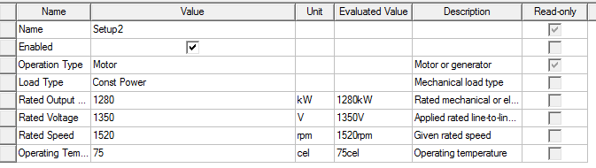

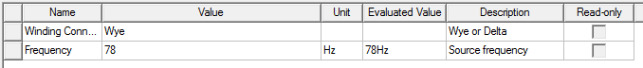

**Results**

Input Current

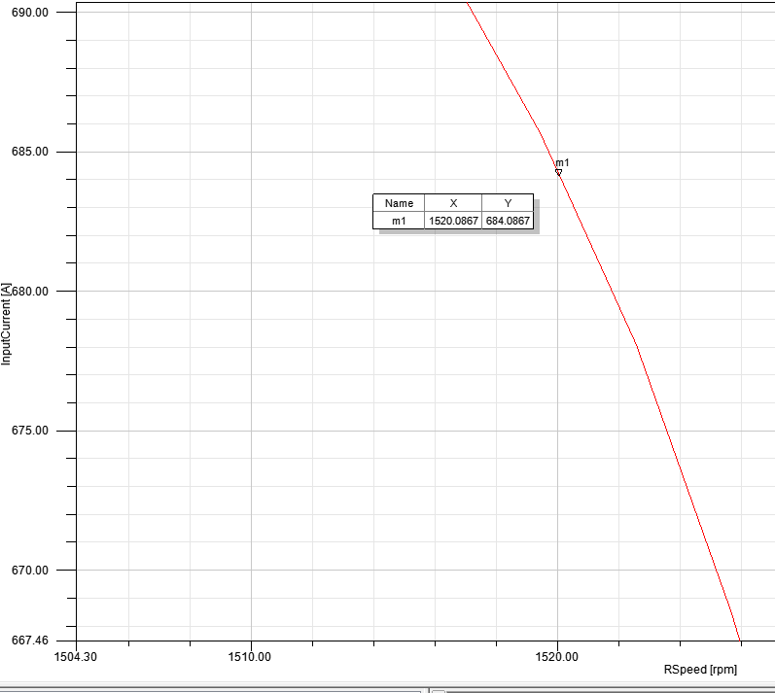

Hand Calculation : 617.85 A

Torque vs Speed Curve

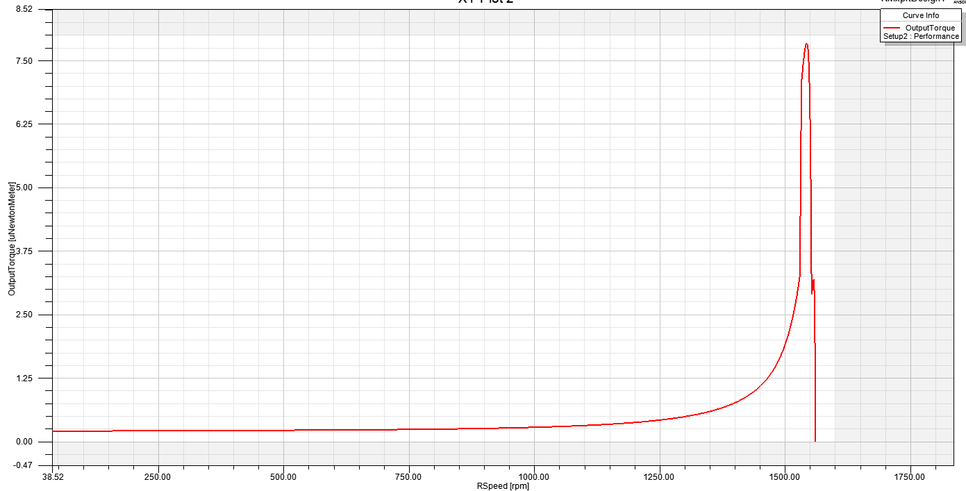

Power vs Speed Curve

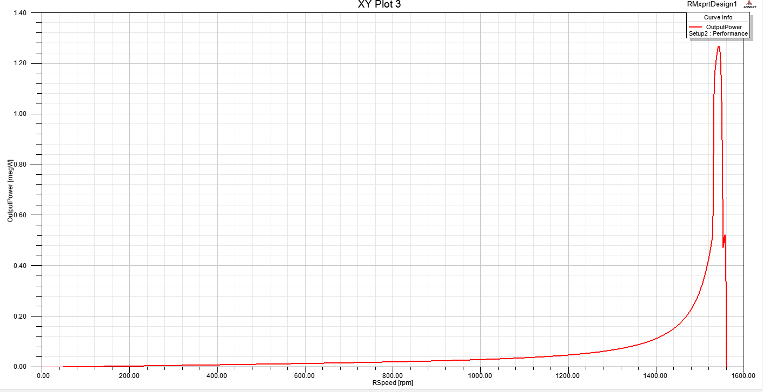

Efficiency vs Speed Curve

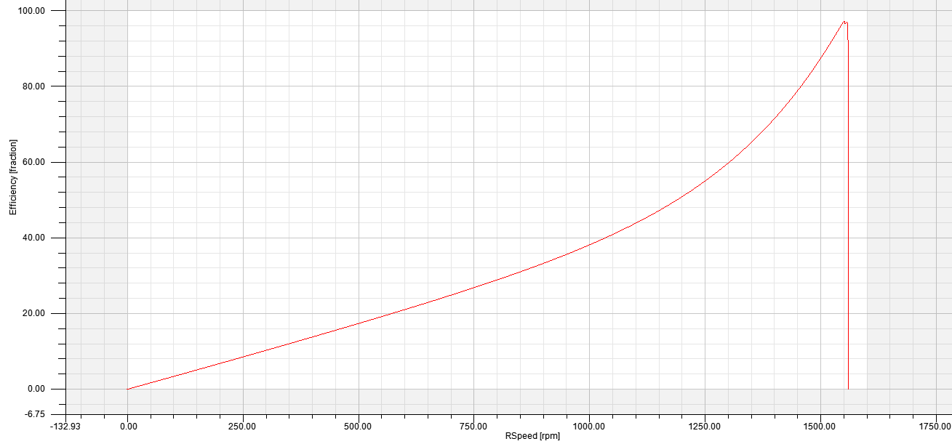

2D Transient Analysis Results

*Model is directly converted from Rmxprt Design*

Setup

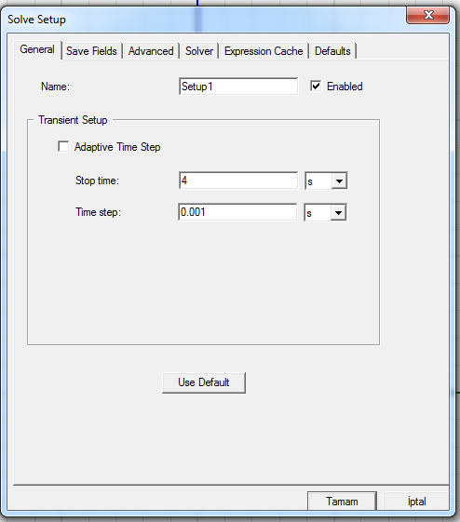

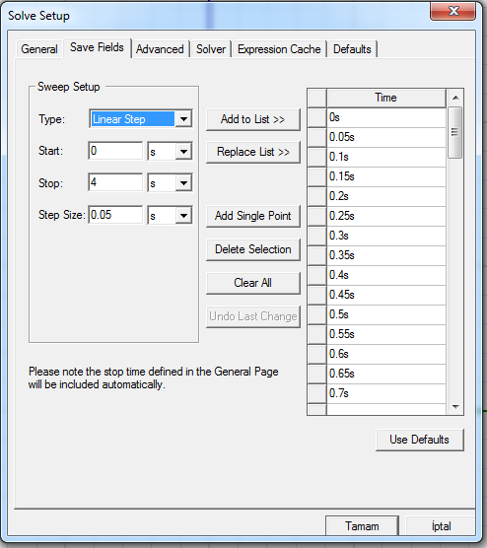

Stator Magnetic Flux Density

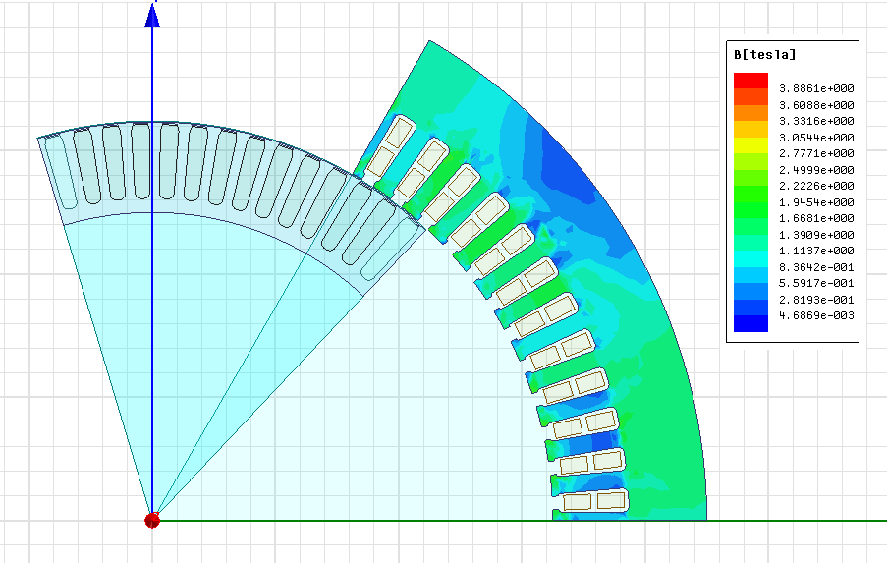

Rotor Magnetic Flux Density

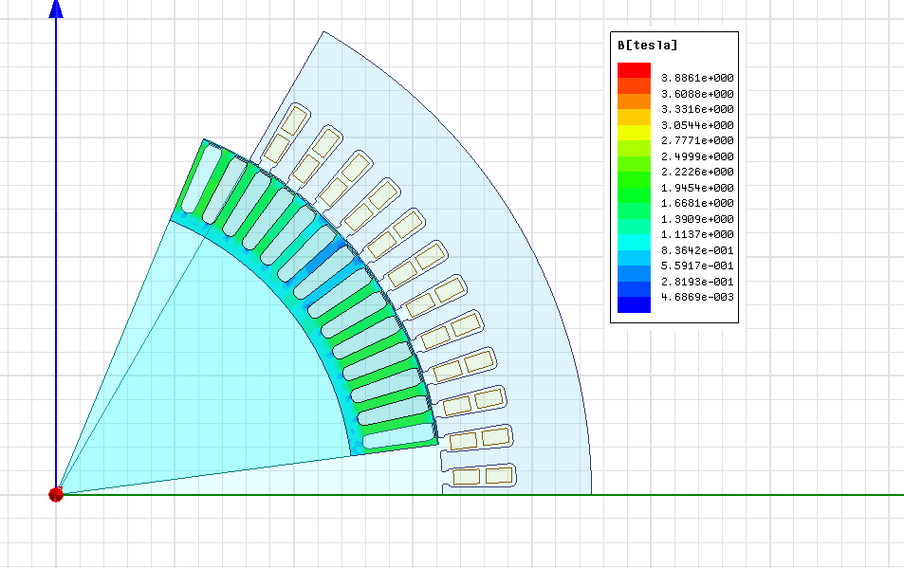

Air Gap Flux Density

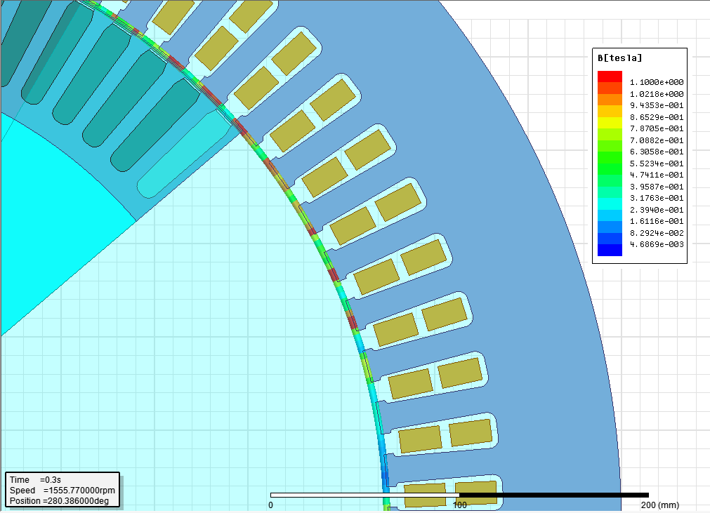

Important Points in Machine Design

* Optimization is greatly helps the performance but to converge faster one should use common design parameters for the start
* Always set your design requirements properly for the application , than start calculating
* Real life manufacturing capabilities should be taken in account ( making the air-gap small is good but not always possible)
* Don’t chose dimensions like 576.234
* Bigger the machine harder the cooling is , lower the electrical loading
* Don forget about the skin effect , use bundled conductors
* Eddy currents are always there
* Working with thinner laminated high tesla cores are good but also expensive
* Don’t forget about the mechanical strength of the materials used
* Insulation should be suitable for the working frequency and the temperature
* There are international standards , make sure you are compatible with
* Adjust the leakage inductance ( if you can) properly for your need
* If you are not designing something very special , have a look at the commercially available products and learn from them
* Money is also a very important design constraint
* Reliability is also a very important design constraint , don’t push the limits too far when optimizing
* Do not parallel the windings or you may burn them
* Put realistic tolerances
* Simulation programs are good as long as you feed them with correct information to process
* Last but not least we still don’t know what magnetic force is so don’t get too cocky